Neil J. Sankar

T00170945

B.Sc. (Hons) in Computing with Mobile App Development

DevOps Project

DevOps

Table of Contents

1. Abstract 2

2. Introduction 2

3. Technologies Used 3

4. Flowchart 7

5. Continuous Integration 7

5.1. GitHub 7

5.2. Travis 8

5.3. Better Code Hub 9

5.4. Building the Code and Configuring the Build Pipeline 11

6. End to end Automation of the Application Delivery Lifecycle 12

6.1. Docker 12

7. Deploying Application 14

8. Conclusion 17

# Abstract

To create an automated deployment pipeline for an application, that will go through several steps of the Build-Test-Deploy pipeline. These include Version Control, Continuous Integration, Continuous Delivery and Continuous Deployment.

# Introduction

This report outlines the steps to implement a fully configured continuous integration/ continuous deployment (CI/CD) pipeline. Implementing a pipeline like this is essential for Dev Ops teams if they want to introduce and release new code changes quickly and without any integration issues with the most recent release. In order to implement a pipeline to demonstrate the effectiveness of such a pipeline, I have decided to use a Python Flask project, based on the basic hello world as a starting point. Flask is a microframework for Python, which enables Python scripts be wrapped in HTML and deployed on the web. (Ronacher, 2019).This project will be created on my host machine. An empty repository will be created on GitHub and the initial Flask project will be pushed up to it. The GitHub repository will be linked to Travis CI. Travis CI will run automated tests on the project every time there is activity on the repository. In theory, if a new file is added to the repository after a successful push, Travis CI should start a new build and run the automated tests again to check that the new files are not causing any issues. Once we can observe that the base code is working and passing all the tests, the code will be examined by Better Code Hub. Better Code Hub analyses the code in the repository on GitHub and tests it against 10 factors of quality. This is a very good tool for developers because it provides quick feedback on all code in the repository every time something is committed. A Docker image is then built on the host machine which can be deployed on Docker Hub. This image will be deployable to Heroku, where it can be accessed as a standalone web app through any web browser.

# Technologies Utilised



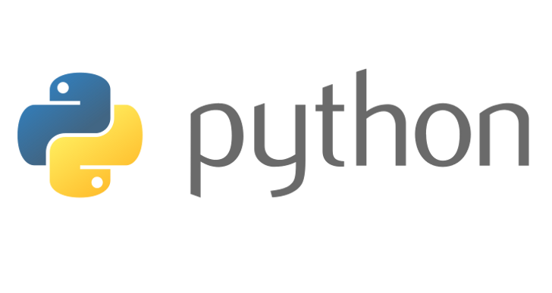







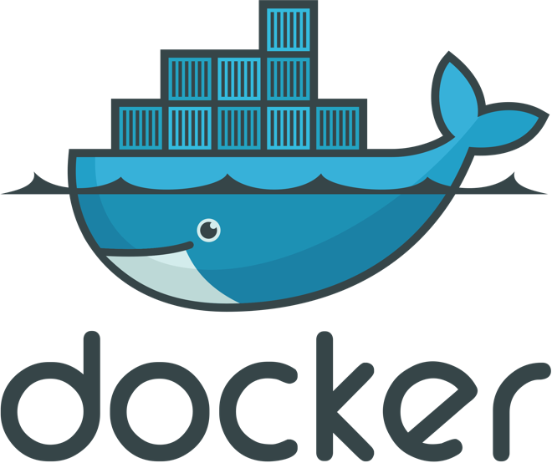



The following technologies were used as follows:

* GitHub was used as the main starting point for this project. As soon as code was pushed to the GitHub repository, a chain of events would take place. All code used in the project was stored in this repository.
* Python, wrapped in the Flask microframework was used as the coded project that was pushed into the repository. The code was implemented with unit tests integrated. These unit tests were very important as they are the ‘yay or nay’ in terms of whether or not the pipeline could build. The repository used for this project can be found at: <https://github.com/robvanderleek/cicd-buzz>
* Travis CI was used as the backbone behind the whole pipeline. As soon as there was activity on the GitHub repository, the automated tests would run. Travis was used to provide feedback on whether or not these tests passed, and if not, would provide feedback to the user on why they didn’t pass. If the tests passed, the code could move on to the code observation and deployment stages respectively.
* Better Code Hub was used as a web-based source code analysis tool that checked the source code of the project for compliancy against the 20 guidelines for Building Maintainable Software. These are:
  + - Number 1: Write short units of code. The shorter the methods and constructers are, the easier the code is to analyse.
    - Number 2: Write simple units of code. Units of code should have as few decision points as possible. This make it easier to analyse the code and understand what it’s doing.
    - Number 3: Write code one. Source code should not be duplicated, as any changes made to one copy, will have to be made in the other.
    - Number 4: Keep unit interfaces small. Units with the least parameters are easier to do tests on and to reuse.
    - Number 5: Separate concerns in modules. Classes that are loosely grouped together are easier to alter and lead to a modular system.
    - Number 6: Couple architecture components loosely. Top level components of a system that are more loosely grouped are easier to alter and lead to a more modular system too.
    - Number 7: Keep architecture components balanced. An architecture that is well balanced, is one that does not have too many or too few components. They are the most modular and can be modified easily.
    - Number 8: Keep your codebase small. The larger the system, the more difficult it is to maintain, because more and more code needs to be analysed and tested, and subsequently changed if it has to changed. The maintenance productivity decreases the larger a system is.
    - Number 9: Automate development pipelines and tests. Automated tests allow for almost instant feedback. Users can learn the benefits of changes to their code in seconds to minutes
    - Number 10: Write clean code. Code should be clean. Dead code like commented out code should not be present as it can confuse those who do not know what the code was meant to do before it was commented out.

(Belderbos, 2019)

* Docker is used to containerize the app, so the process of creating, deploying and running applications is made easier. A docker container of the project was made and configured using a Dockerfile (A file which features everything the containerized app needs to run). An advantage of using Docker is that the host OS system of the device the containerized app is running on is irrelevant to its ability to deploy and run. From there, the container is deployed to Docker Hub as an image. These images allow the flexibility of deploying to multiple different environments. (Red Hat, 2019)
* Heroku, a container based cloud platform that is designed for deploying web apps, is used to deploy the web app in this project. Apps on Heroku once deployed, are accessible through a unique URL.

# Flowchart

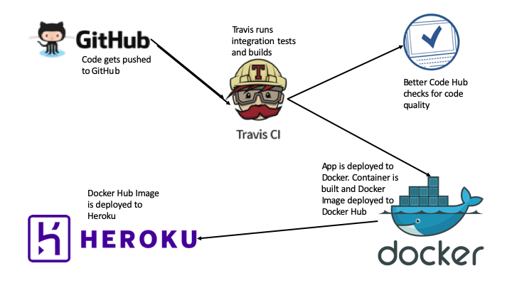

# Continuous Integration

# GitHub

An empty repository called pythonapp was created on GitHub. The app built bit by bit, starting out with an ‘app’ folder, featuring the word_generator.py script containing the functions to generate the words and a blank __init__.py script. A ‘tests’ folder, featuring the test_sentence_generator.py script, containing unit tests was also created. A virtual environment was created and added to the folder. This folder should have been omitted from the repository through using a .gitignore file. This was later corrected. The requirements.txt file contains the line ‘pytest==3.0.6’. This text file was installed into the root folder through the command line interface and tells the test_generator.py script to use pytest for performing unit tests was pushed to GitHub through the command line interface.

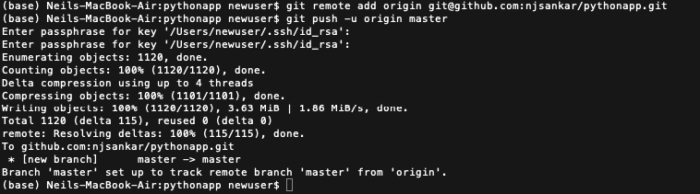

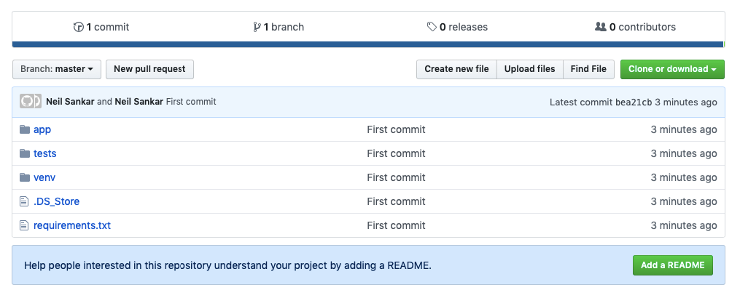

# Travis

In order to connect the GitHub repository with Travis CI, I had to sign up for Travis with my GitHub account details. This paired my two accounts and subsequently allowed me to sync all my repositories to Travis.

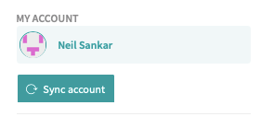

A quick search brought up the repository that I created and pushed to just a few minutes prior. Activating this repository meant that Travis would now attempt to build the project any time there was a change to the repository. Travis would not attempt a built until at least 1 push was made first.



In order to do this a ‘.travis.yml’ needed to be created. This file is a set of details and instructions Travis uses to know what type of code it is dealing with and what to try and do with it. In this case, code was:

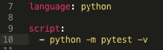

This piece of code tells Travis that the language the code is in is Python and the line of code it is to execute in order to build is the test script. When ‘.travis.yml was pushed to the repository, there was an immediate build started.

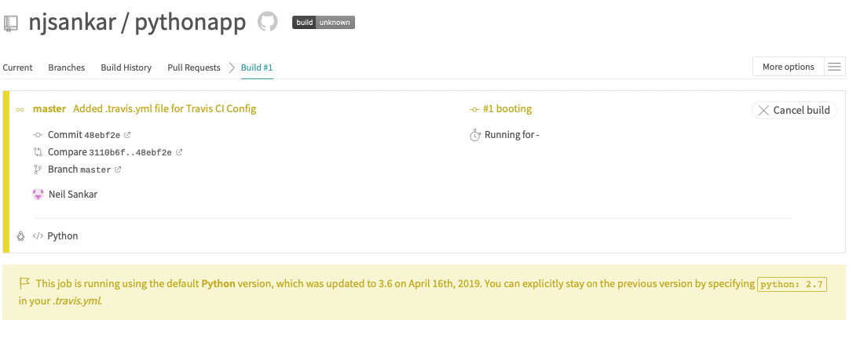

Travis spotted the change and attempted its first build. The resulting output was:

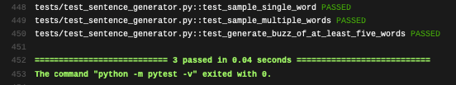

What this shows is that all 3 test functions in the test_sentence_generator.py script passed successfully.

# Better Code Hub

The next part of this project to implement was a way to check for code quality. For this I used Better Code Hub.

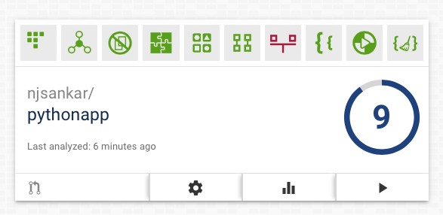

Like Travis, Better Code Hub is connectible through GitHub. Due to that, the moment you log in, all your repositories are there to be tested for code quality. Simply clicking the play button starts the quality test which only takes a few seconds.

An example of these code quality checks is clear from the example shown below. In this instance, the venv folder was pushed to the repository, as the .gitignore file hadn’t been added to the repository before the push. As a result of this, the code only scored 5 / 10. A lot of this was down to the sheer number of files and complexity of the methods in these files, which as shown in part 3 of this document, goes against the code standards the Better Code Hub algorithm is based on.

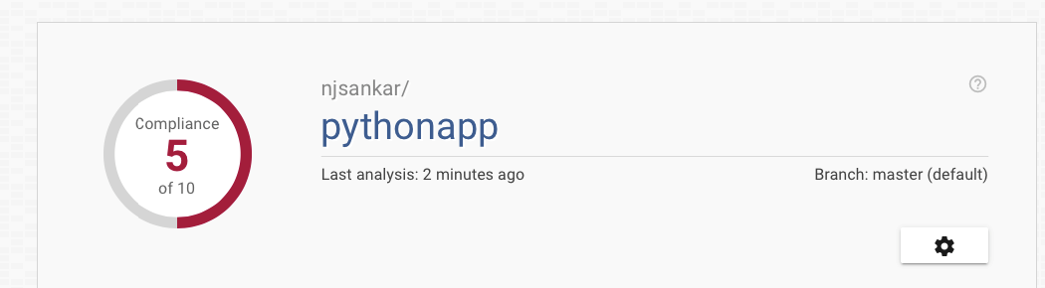

Eventually when .gitignore file was pushed and the venv folder was removed from the repository, the score increased to 9 / 10.

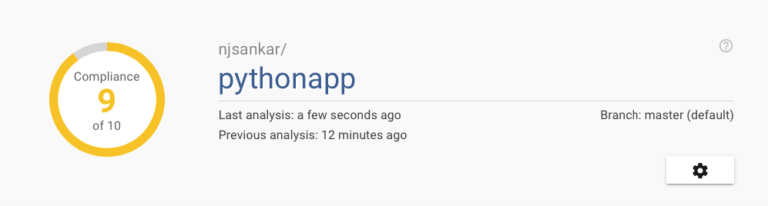

# Building the Code and Configuring the Build Pipeline

This section continues on from the previous section, and adds more development to the code already in the repository. In this case, a new file called app.py was created, which takes the output of the word_generator.py file and wraps it in HTML. It was import for the tests to still pass in this section, as this was the final stop before deploying to Docker. Another change to the code was to update the requirements.txt file to now include flask for the new code to run. This change, when pushed, passed.



Now that the code was now fully developed as far as it needed to go. The app was now deployable on the browser by running python app.py. The output of this was:

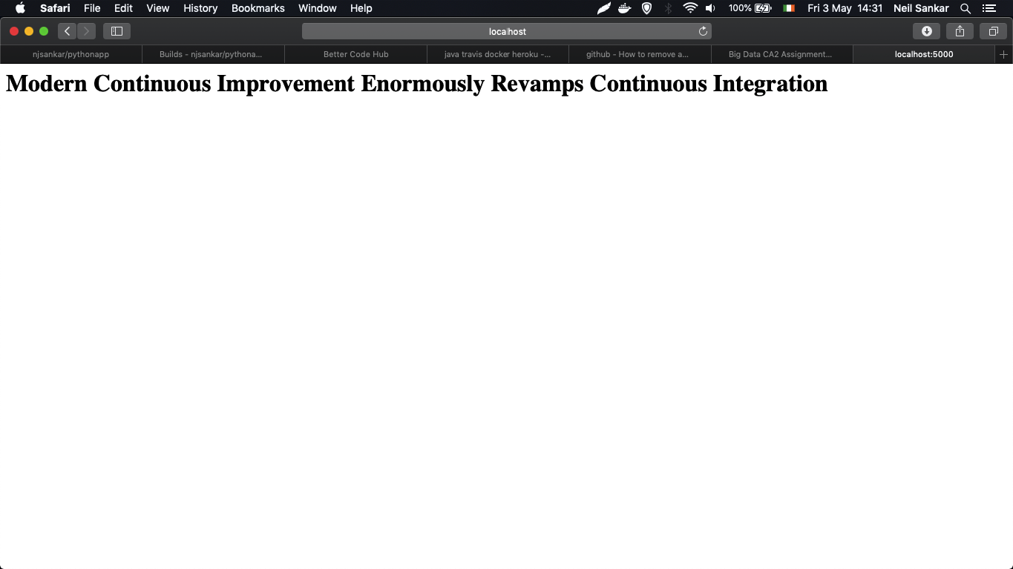

Now that there is a fully buildable app that passed all its tests and had high code quality, we could move on to deploying to Docker

# End to end Automation of the Application Delivery Lifecycle

# Docker

Docker is Open Source and freely downloadable from hub.docker.com.

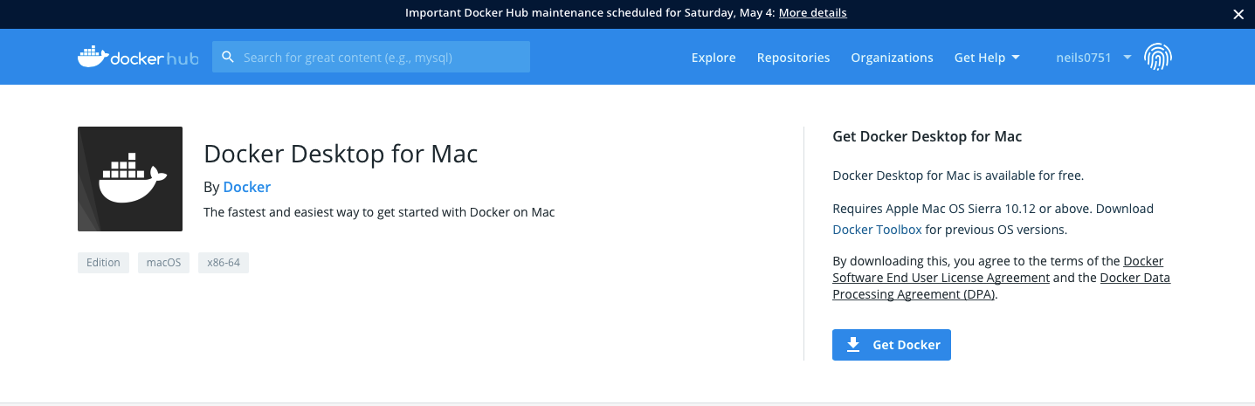

Once it’s download, and the steps are followed and you are signed up Docker, it is ready on the host machine.

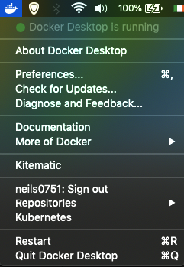

Docker is ready to be activate by typing ‘docker’ in the command line. In order to create a new docker image, a Dockerfile had to be created. The Docker file is a file which features everything the app needs in order to run. The content of the Dockerfile are:

FROM alpine:3.5 – User alpine 3.5

RUN apk add --update python py-pip – update python

COPY requirements.txt /src/requirements.txt – Copy the requirements.txt file from the root directory

RUN pip install -r /src/requirements.txt – install pytest 3.0.6 and flask 0.12

COPY app.py /src – Copy app.py

COPY app /src/app – Copy the app folder

CMD python /src/app.py – Execute the app.py script

Once the Dockerfile container image is created, this command needed to be issued:



The result was as follows:



As shown above, all the commands in the Dockerfile are executed and the Docker image is created and called pythonapp:latest.

This container can be ween when the ‘docker image ls’ command is issued. This command shows all the docker containerimages that exist on the host computer.



This docker can be run on the users host browser by issuing:



The output of which is:



Before the Docker image can be fully linked to future Travis builds, the following environment variables have to be set in Travis:



# Deploying Application

In this section, the app will be deployed to Heroku. Heroku is designed to deploy web apps so it is the ideal method of deployment. Heroku only provide 5 free projects before there is a fee.

In order to use Heroku, the Heroku CLI will need to be downloaded.



Once it is installed, the process of deploy your docker container image to Heroku is quick. First you must login through the browser. Entering the command bellow will load the login screen on the host browser.





Next is to create a new blank Heroku app:



This app is instantly available to visit, and can be quickly visited by typing in the web address written in light blue



Next is to install the container-registry plugin. This is essential for being able to deploy to Heroku from Docker



You must then log in the container by typing ‘heroku container:login’, followed by ‘heroku container:push web’ to push the image to web deployment then finally type ‘heroku container:release web’ to launch the website. The website can be loaded in the host browser by typing ‘heroku open’. The out is:



The site can also be reached by viewing the list of created app on the Heroku site and by pressing ‘Open app’



# Conclusion

This concludes the development of a build pipeline using a Python project, GitHub, Travis CI, Docker and Heroku. It was a relatively straightforward implementation to do. I found trying to implement a similar pipeline on Jenkins and Team City to be an arduous task with a slow rate of progress. In terms of this implementation, finding a basic python-flask program that featured unit tests was quite a challenge. Most example of pre made applications all had an sqllite or MongoDB database running in the background of operations. Travis CI is a very popular tool for running tests and building projects and it’s not hard to see why. It was very quick to get working and made what is arguably the most important stage of the pipeline work very easily with no hassle. If I was to do this project again, I would be happy to work with Travis, Docker and Heroku, but perhaps would try an AngularJS or React app instead.